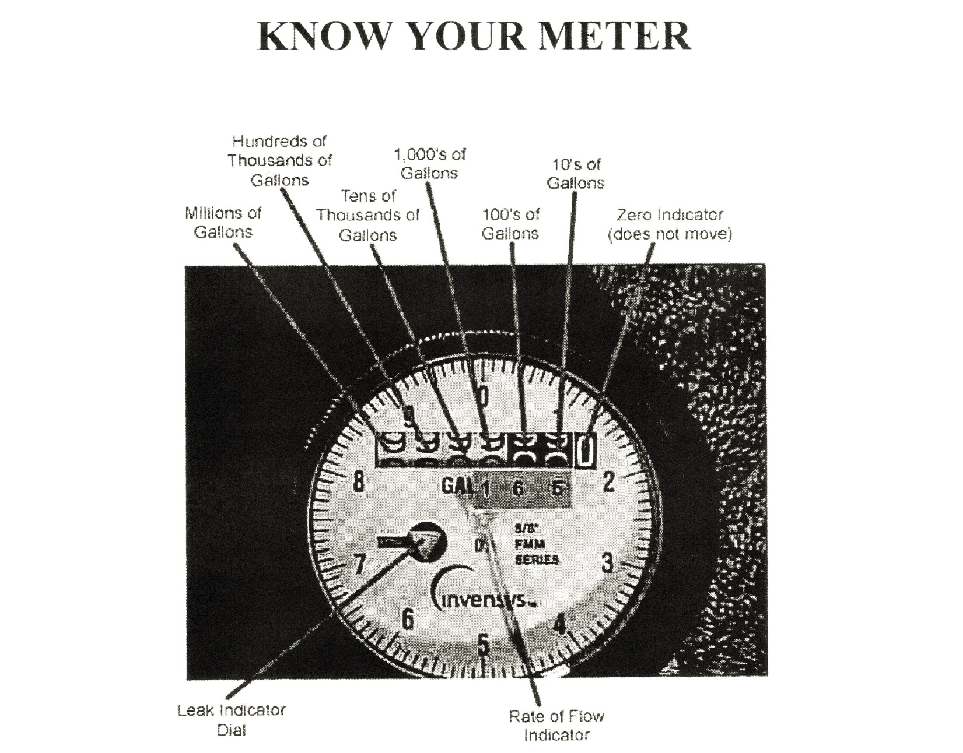
Every customer is responsible to read their own meter each month and report that reading on the payment stub for the monthly water bill.
How to Read Your Meter
The meter is read from left to right. Look at the sample reading located just below the register. The reading is one thousand six hundred and 50 gallons of water. The Rate of Flow indicator will register 10 gallons with each rotation, thus causing the 10’s of gallons to roll by one number. Sunko WSC bills in hundreds of gallons or greater. The Leak Detector Dial may help you determine if you have a leak in your service line when you suspect a higher than normal meter reading or low water pressure. To check for a potential leak, turn off all sources of water in your home and also turn off the valve in your meter box and wait about 10 minutes. Turn the valve in the meter box back on slowly and then look at the Leak Detector Dial. If the detector is spinning at a fairly rapid rate you may have a leak in your line. This instrument is capable of detecting even the slightest amount of flow. The greater the spinning speed on the dial, the greater the volume of flow.
If you still suspect a leak and cannot determine where it is, please feel free to call the office and we will try to assist you.

